Q1)

Ans : -

<!DOCTYPE html>
<html lang="en">
<head>
<meta charset="UTF-8">
<meta name="viewport" content="width=device-width, initial-scale=1.0">
<title>Assignment 1</title>
</head>
<body>
<img src="file:///C:/Users/DELL/Downloads/download.jpeg" alt="Image 1">
<img src="file:///C:/Users/DELL/Downloads/download%20(1).jpeg" alt="Image 2">
<img src="file:///C:/Users/DELL/Downloads/download%20(2).jpeg" alt="Image 3">
<img src="file:///C:/Users/DELL/Downloads/download%20(3).jpeg" alt="Image 4">
<img src="file:///C:/Users/DELL/Downloads/download%20(4).jpeg" alt="Image 5">
<img src="file:///C:/Users/DELL/Downloads/download%20(5).jpeg" alt="Image 6">
<img src="file:///C:/Users/DELL/Downloads/download%20(6).jpeg" alt="Image 7">
<img src="file:///C:/Users/DELL/Downloads/download%20(7).jpeg" alt="Image 8">
<img src="file:///C:/Users/DELL/Downloads/download%20(8).jpeg" alt="Image 9">
</body>
</html>

OUTPUT : -

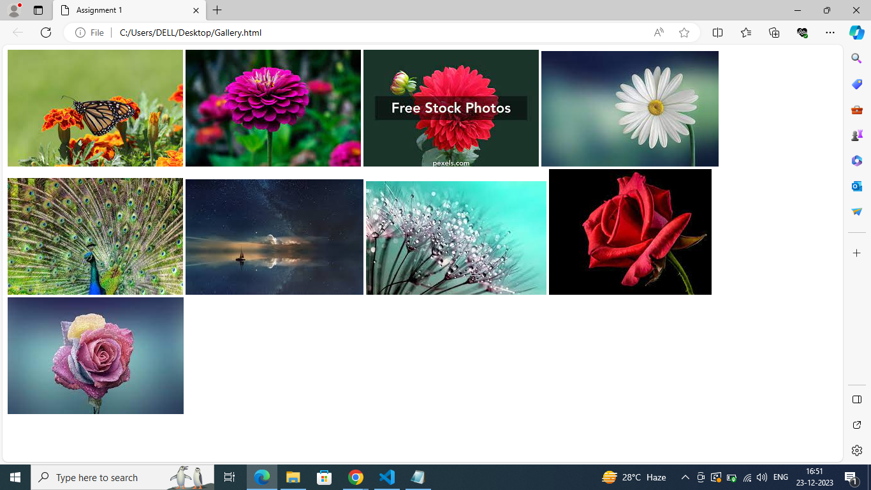

2Q)

Ans : -
<!DOCTYPE html>
<html lang="en">
<head>
<meta charset="UTF-8">
<meta name="viewport" content="width=device-width, initial-scale=1.0">
<title>Video And Audio</title>
</head>
<body>
<video width="640" height="340" controls src="file:///C:/Users/DELL/Downloads/mixkit-going-down-a-curved-highway-through-a-mountain-range-41576-medium.mp4" type="video/mp4"
></video>

<audio controls src="file:///C:/Users/DELL/Downloads/sare-jahan-se-acha-beautifully-remastered-30952.mp3" type="audio/mp3"></audio>
</body>
</html>

OUTPUT : -

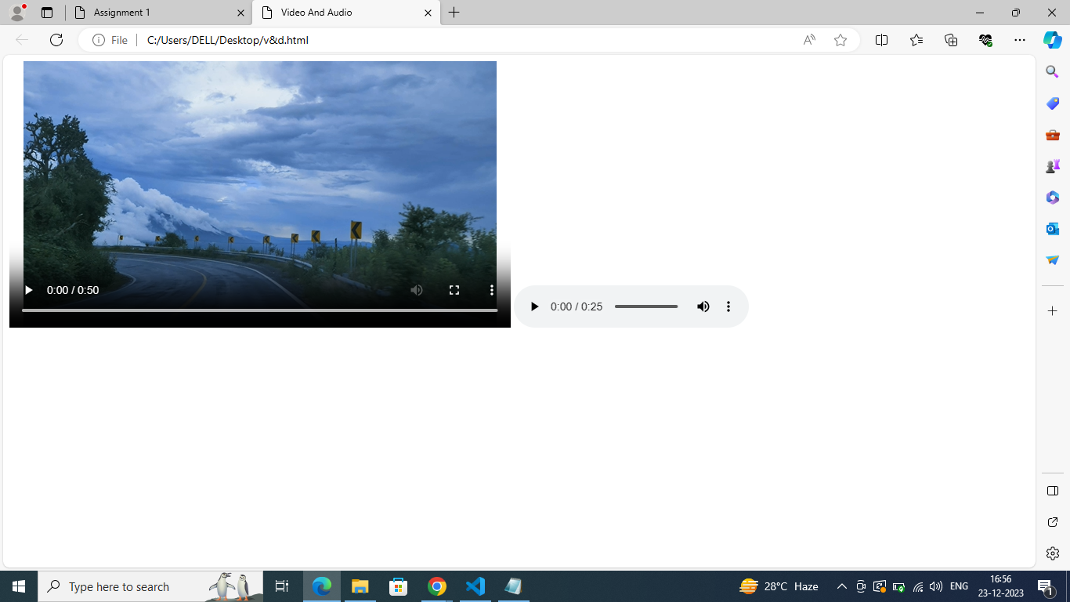

3Q)

Ans : -

<!DOCTYPE html>
<html lang="en">
<head>
<meta charset="UTF-8">
<meta name="viewport" content="width=device-width, initial-scale=1.0">
<title>Video And Audio</title>
</head>
<body>
<video width="640" height="340" controls muted autoplay loop src="file:///C:/Users/DELL/Downloads/mixkit-going-down-a-curved-highway-through-a-mountain-range-41576-medium.mp4" type="video/mp4"
></video>

<audio controls muted autoplay loop src="file:///C:/Users/DELL/Downloads/sare-jahan-se-acha-beautifully-remastered-30952.mp3" type="audio/mp3"></audio>
</body>
</html>

OUTPUT : -

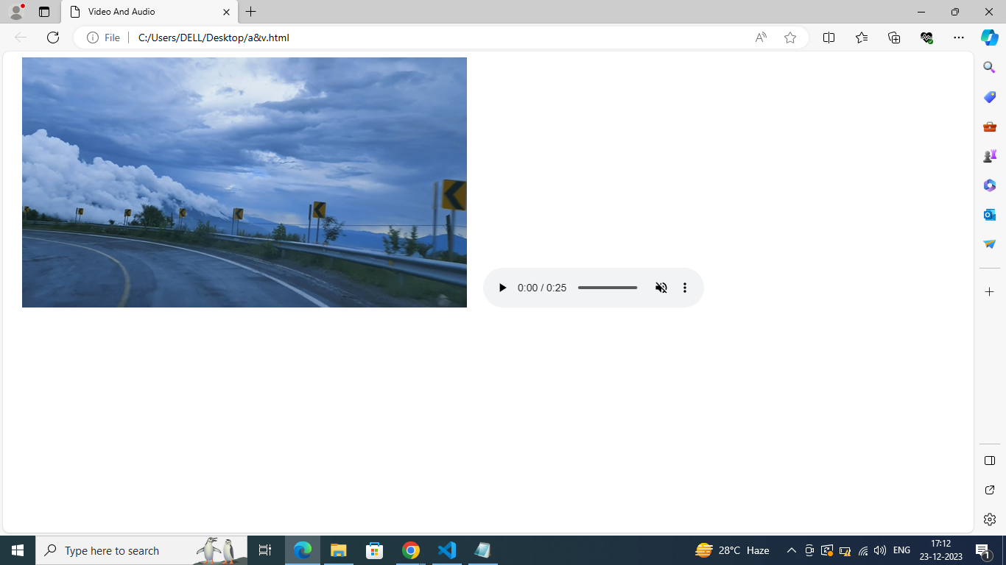

4Q)

Ans : -

<!DOCTYPE html>
<html lang="en">
<head>
<meta charset="UTF-8">
<meta name="viewport" content="width=device-width, initial-scale=1.0">
<title>iFrame</title>
</head>
<body>
<iframe src="https://en.wikipedia.org/wiki/Physics_Wallah" style="border: 0px #ffffff none;" name="myiFrame"
scrolling="yes" frameborder="1" margineheight="0px" marginewidth="0px" height="400px"
width="600px" allowfullscreen ></iframe>
</body>
</html>

OUTPUT : -

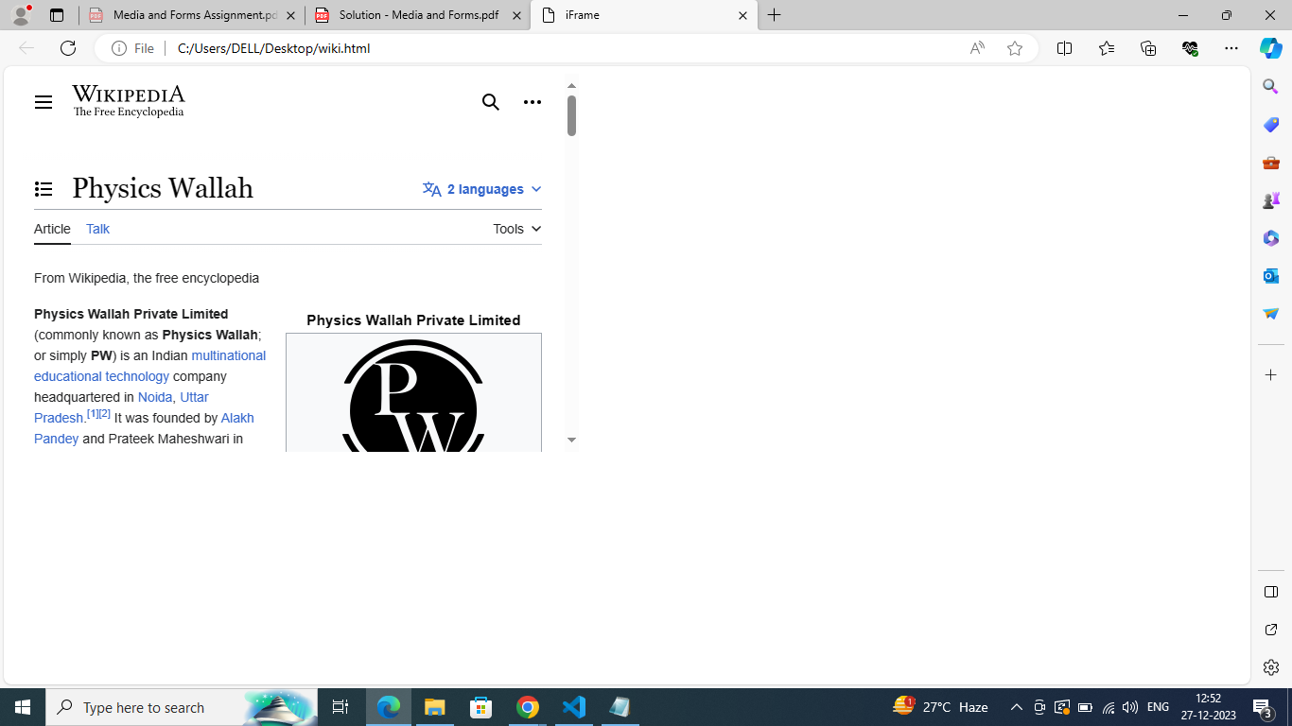

Q5)

Ans : -

<!DOCTYPE html>
<html lang="en">
<head>
<meta charset="UTF-8">
<meta name="viewport" content="width=device-width, initial-scale=1.0">
<title>Form</title>
</head>
<body>
<form>
<label for="first name">: First name
<input type="text" name="first name" placeholder="Arshiya Urooj" id="first name" required minlength="3" maxlength="20"/>
</label>
<br>
<label for="last name">:Last name
<input type="text" name="last name" placeholder="Younus" id="last name" required minlength="3" maxlength="20"/>
</label>
<br>
<label for="email">:Email
<input type="text" name="email" placeholder="younusarshiyaurooj@gmail.com" id="email" required/>
</label>
<br>
<label for="password">:Password
<input type="text" name="password" placeholder="*********" id="password" required min=8/>
</label>
<br>
<label for="age">:Age
<input type="number" name="age" placeholder="22" id="age" required min=0 max=150/>
</label>
<br>
<label for="gender">:Gender
<input type="radio" id="male" value="male" name="gender" checked />
<label for="male">:Male</label>
<input type="radio" id="female" value="female" name="gender" checked />
<label for="female">:Female</label>
<input type="radio" id="other" value="other" name="gender" checked />
<label for="other">:Other</label>
</label>
<br>
<label for="terms">Terms:
<input type="checkbox" id="terms" required /> I agree to terms and conditions</label>
<br>
<button type="submit">Register</button>
</form>
</body>
</html>

OUTPUT : -

